
Durham, North Carolina

Monthly Payment Authorization Form
(Recurring)
Complete and sign this form to authorize Federal Parking to debit your checking/savings account or credit/debit card for recurring monthly payment of your parking fee. All applicable information must be accurate or the bank may reject the form and assess a fee.

Please complete the information below:

I, ____________________________, (full name) authorize Federal Parking to charge my checking/savings account or credit/debit card indicated below in the amount of $50.60 per month (or the amount based on the parking rate agreed upon by Durham VAMC and Federal Parking) for Garage A parking beginning ____________________ (month & year). The billing window is the 28th of the previous month to the 4th of the billed month.

Billing Address _______________________________ Phone# ______________________________
City, State, Zip _______________________________ Email ______________________________
Soc. Sec. # _______________________________

Checking/Savings (ACH) or Credit/Debit Card
Checking Savings  Name on Account __________________________  Bank Name __________________________  Account Number __________________________  Bank Routing # __________________________  Bank City/State __________________________  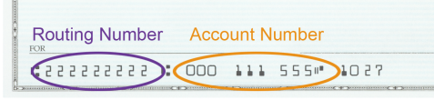 |  | Visa MasterCard  Amex Discover  Cardholder Name ________________________  Account Number ________________________  Expiration Date ________________  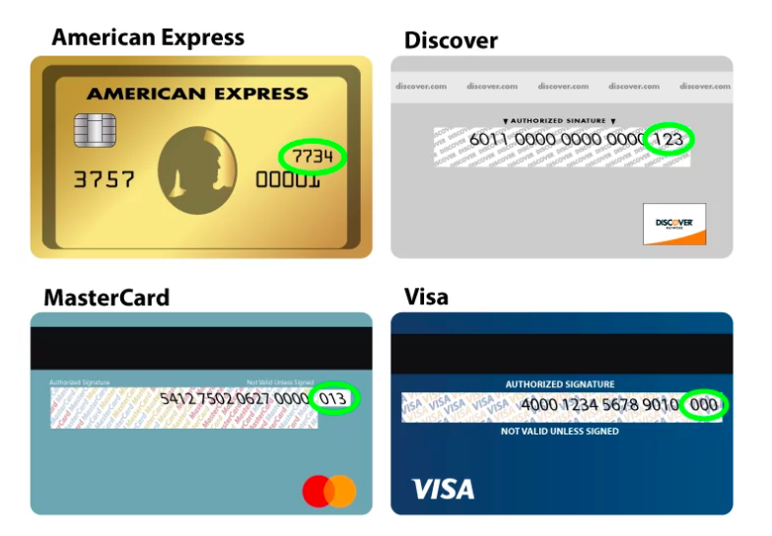  Card Security Code ______ (3 or 4 digits)

SIGNATURE DATE

I authorize Federal Parking to charge the account indicated above for the services described and for the amount indicated. I certify that I am an authorized user of this bank account or credit/debit card and that I will not dispute the payment with my financial institution, so long as the transaction corresponds to the terms indicated in this form. I understand that this authorization, if for recurring payments, will remain in effect until I have signed, in person, a cancellation form provided by Federal Parking, upon receipt of which Federal Parking will provide written acknowledgment of cancellation upon request, which I shall retain for at least one year.

