
Durham, North Carolina

Annual Drive 12-Month Advance Payment Authorization Form
(One-Time or Recurring Annually)
Complete and sign this form to authorize Federal Parking to debit your checking/savings account for a 12-month advance payment of your parking fee. You can choose this to be done on a one-time or annually recurring basis. All applicable information must be accurate or the bank may reject the form and assess a fee.

Please complete the information below:

I, ____________________________, (full name) authorize Federal Parking to charge my checking/savings account indicated below in the amount of $735.96 for 12 months of Garage A parking at $61.33 per month (or the amount based on the parking rate agreed upon by Durham VAMC and Federal Parking) beginning October 1 of the current year.

Billing Address _______________________________ Phone# ______________________________
City, State, Zip _______________________________ Email ______________________________
Soc. Sec. # _______________________________

Please indicate whether this will be a one-time or a recurring transaction: One-Time Recurring

Checking/Savings (ACH)
Checking Savings
Name on Account __________________________
Bank Name __________________________
Account Number __________________________
Bank Routing # __________________________
Bank City/State __________________________
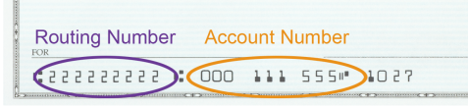

SIGNATURE DATE

I authorize Federal Parking to charge the account indicated above for the services described and for the amount indicated. I certify that I am an authorized user of this bank account or credit/debit card and that I will not dispute the payment with my financial institution, so long as the transaction corresponds to the terms indicated in this form. I understand that this authorization, if for recurring payments, will remain in effect until I have signed, in person, a cancellation form provided by Federal Parking, upon receipt of which Federal Parking will provide written acknowledgment of cancellation upon request, which I shall retain for at least one year.

